## Associations among morphotypes and species-specific genotypes around Kola Peninsular

Table ++. Parameters of regression models fitted

|  |  |  |  |  |
| --- | --- | --- | --- | --- |
| Terms | Estimate | SE | z-statistic | p-value |
| **Model 1** | $pseudoR^{2}$ = 0.38 |  |  |  |
| (Intercept) | -2.7 | 0.15 | -18.23 | < 0.001 |
| Ptros | 4.7 | 0.28 | 16.58 | < 0.001 |
| Subset(BL) | 0.2 | 0.26 | 0.62 | 0.537 |
| Subset(BH) | 2.2 | 0.19 | 11.30 | < 0.001 |
| Ptros:Subset(BL) | -0.5 | 0.45 | -1.03 | 0.302 |
| Ptros:Subset(BH) | -1.4 | 0.43 | -3.38 | 0.001 |
| **Model 2** | $pseudoR_{m}^{2}$ = 0.57 | $pseudoR_{c}^{2}$ = 0.64 |  |  |
| (Intercept) | -4.2 | 0.38 | -10.89 | < 0.001 |
| Ptros | 4.7 | 0.82 | 5.80 | < 0.001 |
| Subset(BL) | 0.3 | 0.75 | 0.40 | 0.688 |
| Subset(BH) | 3.5 | 0.57 | 6.18 | < 0.001 |
| Species(*M.trossulus*) | 4.2 | 0.45 | 9.34 | < 0.001 |
| Ptros:Subset(BL) | -1.9 | 1.51 | -1.24 | 0.214 |
| Ptros:Subset(BH) | -1.8 | 1.29 | -1.36 | 0.174 |
| Ptros:Species(*M.trossulus*) | -2.5 | 0.83 | -3.02 | 0.003 |
| Subset(BL):Species(*M.trossulus*) | -0.5 | 0.77 | -0.61 | 0.54 |
| Subset(BH):Species(*M.trossulus*) | -3 | 0.62 | -4.87 | < 0.001 |
| Ptros:Subset(BL):Species(*M.trossulus*) | 2.2 | 1.46 | 1.52 | 0.129 |
| Ptros:Subset(BH):Species(*M.trossulus*) | 2.5 | 1.25 | 1.96 | 0.05 |
| sd_(Intercept).pop | 0.8 |  |  |  |
| **Model 3** | $pseudoR^{2}$ = 0.17 |  |  |  |
| (Intercept) | 2.6 | 0.16 | 16.58 | < 0.001 |
| Ptros | -1.9 | 0.28 | -6.82 | < 0.001 |
| Subset(BL) | -0.4 | 0.28 | -1.53 | 0.127 |
| Subset(BH) | -2.4 | 0.2 | -12.29 | < 0.001 |
| Ptros:Subset(BL) | 1.1 | 0.47 | 2.26 | 0.024 |
| Ptros:Subset(BH) | 2.6 | 0.39 | 6.66 | < 0.001 |
| **Model 4** | $pseudoR_{m}^{2}$ = 0.4 | $pseudoR_{c}^{2}$ = 0.42 |  |  |
| (Intercept) | 3.8 | 0.28 | 13.99 | < 0.001 |
| Morph(T) | -3.8 | 0.41 | -9.12 | < 0.001 |
| Ptros | -5.2 | 0.55 | -9.57 | < 0.001 |
| Subset(BL) | -0.4 | 0.47 | -0.88 | 0.377 |
| Subset(BH) | -0.6 | 0.47 | -1.21 | 0.226 |
| Morph(T):Ptros | 8.1 | 0.78 | 10.40 | < 0.001 |
| Morph(T):Subset(BL) | 0.8 | 0.73 | 1.09 | 0.276 |
| Morph(T):Subset(BH) | -1.6 | 0.58 | -2.71 | 0.007 |
| Ptros:Subset(BL) | 0.8 | 0.9 | 0.91 | 0.361 |
| Ptros:Subset(BH) | 0.4 | 1.02 | 0.36 | 0.72 |
| Morph(T):Ptros:Subset(BL) | -0.3 | 1.37 | -0.21 | 0.83 |
| Morph(T):Ptros:Subset(BH) | 1.4 | 1.2 | 1.16 | 0.244 |
| sd_(Intercept).pop | 0.3 |  |  |  |
| **Model 5** | $pseudoR^{2}$ = 0.42 |  |  |  |
| (Intercept) | -2.5 | 0.14 | -17.97 | < 0.001 |
| PT | 5.3 | 0.32 | 16.73 | < 0.001 |
| Subset(BL) | 0.3 | 0.25 | 1.12 | 0.264 |
| Subset(BH) | -1.3 | 0.33 | -4.06 | < 0.001 |
| PT:Subset(BL) | 0.3 | 0.58 | 0.54 | 0.588 |
| PT:Subset(BH) | -0.3 | 0.53 | -0.54 | 0.591 |
| **Model 6** | $pseudoR_{m}^{2}$ = 0.5 | $pseudoR_{c}^{2}$ = 0.51 |  |  |
| (Intercept) | 3.7 | 0.21 | 17.23 | < 0.001 |
| Morph(T) | -3.5 | 0.33 | -10.50 | < 0.001 |
| Ptros | -4.9 | 0.41 | -12.00 | < 0.001 |
| Subset(BH) | -0.4 | 0.43 | -1.00 | 0.318 |
| SubsetGOM | 1 | 0.58 | 1.78 | 0.074 |
| SubsetBALT | -0.9 | 0.41 | -2.28 | 0.023 |
| SubsetNORW | -0.6 | 0.61 | -1.00 | 0.315 |
| Morph(T):Ptros | 8.1 | 0.63 | 12.90 | < 0.001 |
| Morph(T):Subset(BH) | -1.8 | 0.53 | -3.43 | 0.001 |
| Morph(T):SubsetGOM | -1.8 | 0.84 | -2.18 | 0.029 |
| Morph(T):SubsetBALT | 0.4 | 1.54 | 0.23 | 0.82 |
| Morph(T):SubsetNORW | -1.1 | 1.17 | -0.95 | 0.343 |
| Ptros:Subset(BH) | 0.1 | 0.93 | 0.09 | 0.928 |
| Ptros:SubsetGOM | -3.2 | 1.08 | -2.92 | 0.003 |
| Ptros:SubsetBALT | -0.5 | 0.72 | -0.72 | 0.47 |
| Ptros:SubsetNORW | 0 | 0.95 | -0.05 | 0.959 |
| Morph(T):Ptros:Subset(BH) | 1.4 | 1.1 | 1.27 | 0.204 |
| Morph(T):Ptros:SubsetGOM | 4.8 | 1.88 | 2.57 | 0.01 |
| Morph(T):Ptros:SubsetBALT | 1.2 | 2.2 | 0.55 | 0.579 |
| Morph(T):Ptros:SubsetNORW | 3.6 | 1.94 | 1.86 | 0.063 |
| sd_(Intercept).pop | 0.3 |  |  |  |
| **Model 7** | $pseudoR_{m}^{2}$ = 0.42 |  |  |  |
| (Intercept) | -2.4 | 0.11 | -21.34 | < 0.001 |
| PT | 5.4 | 0.26 | 20.74 | < 0.001 |
| Subset(BH) | -1.5 | 0.32 | -4.55 | < 0.001 |
| SubsetGOM | 0.1 | 0.22 | 0.69 | 0.492 |
| SubsetBALT | 1.8 | 0.16 | 11.01 | < 0.001 |
| SubsetNORW | 1.9 | 0.22 | 8.91 | < 0.001 |
| PT:Subset(BH) | -0.4 | 0.5 | -0.87 | 0.386 |
| PT:SubsetGOM | 0.8 | 0.74 | 1.04 | 0.299 |
| PT:SubsetBALT | 6.1 | 1.22 | 5.05 | < 0.001 |
| PT:SubsetNORW | -1.8 | 0.62 | -2.81 | 0.005 |
| **Model 8** | $pseudoR_{m}^{2}$ = 0.57 | $pseudoR_{c}^{2}$ = 0.66 |  |  |
| (Intercept) | -4.2 | 0.36 | -11.64 | < 0.001 |
| Ptros | 4.2 | 0.74 | 5.70 | < 0.001 |
| Subset(BH) | 3.6 | 0.62 | 5.77 | < 0.001 |
| SubsetGOM | 0.4 | 0.63 | 0.55 | 0.579 |
| SubsetBALT | -2.8 | 1.7 | -1.63 | 0.102 |
| SubsetNORW | 1.3 | 1.05 | 1.27 | 0.205 |
| Species(*M.trossulus*) | 4.1 | 0.37 | 11.04 | < 0.001 |
| Ptros:Subset(BH) | -1.1 | 1.37 | -0.82 | 0.414 |
| Ptros:SubsetGOM | -1.7 | 1.76 | -0.98 | 0.326 |
| Ptros:SubsetBALT | 1.3 | 2.56 | 0.51 | 0.612 |
| Ptros:SubsetNORW | -5.7 | 2.04 | -2.79 | 0.005 |
| Ptros:Species(*M.trossulus*) | -1.7 | 0.68 | -2.45 | 0.014 |
| Subset(BH):Species(*M.trossulus*) | -2.9 | 0.57 | -5.16 | < 0.001 |
| SubsetGOM:Species(*M.trossulus*) | 0.5 | 0.98 | 0.52 | 0.605 |
| SubsetBALT:Species(*M.trossulus*) | -1.4 | 1.64 | -0.85 | 0.397 |
| SubsetNORW:Species(*M.trossulus*) | -2.3 | 1.28 | -1.82 | 0.069 |
| Ptros:Subset(BH):Species(*M.trossulus*) | 1.6 | 1.17 | 1.41 | 0.159 |
| Ptros:SubsetGOM:Species(*M.trossulus*) | -2.1 | 2.02 | -1.04 | 0.296 |
| Ptros:SubsetBALT:Species(*M.trossulus*) | -0.4 | 2.41 | -0.17 | 0.863 |
| Ptros:SubsetNORW:Species(*M.trossulus*) | 3.5 | 2.03 | 1.73 | 0.083 |
| sd_(Intercept).pop | 0.9 |  |  |  |

## The value of morphotype-test for prediction of mussel’s taxa around Kola Peninsular

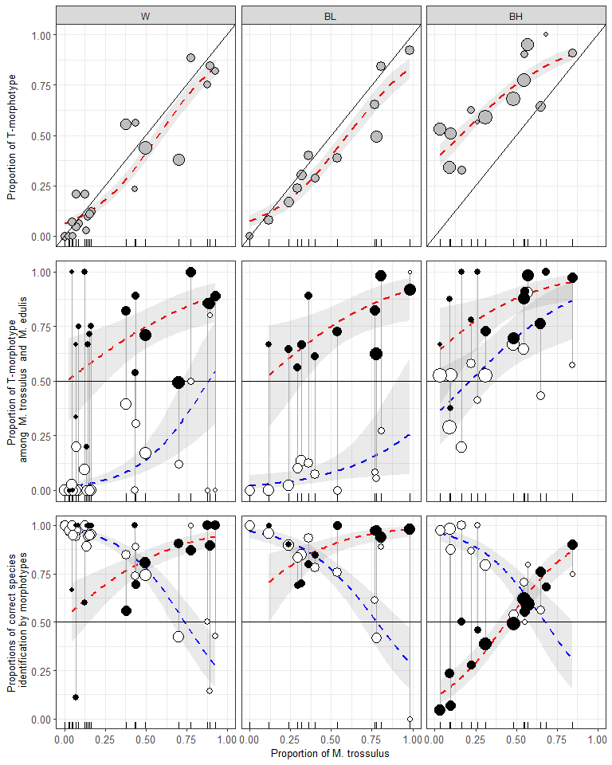

Figure ++. Variation of PT, P(T|tros), P(E|edu), P(tros|T), P(edu|E) as functions of Ptros in the White Sea (WS), brackish Barents Sea (BL) and saline Barents Sea (BH). Points - empirical estimates, size is proportional to sample sizes. Lines – regression model predictions, grey filling – 95% confidence intervals of regressions. (A) Proportions of T-morphotypes (PT) (Model 1). (B). Proportions of T-morphotypes among M. trossulus (filled points) and M. edulis (empty points) (Model 2). (C) Frequencies of M. trossulus among T-morphotypes (filled points) and of M. edulis among E-morphotypes (Model 4). Vertical lines on B and C connect subsamples of *M. trossulus* and *M. edulis* from the same samples.

Для параноиков. Таблицы с оценкой статистической значимости связи вероятности встретить Т-морфотип с размером

**Для M.trossulus**

|  |  |  |  |  |  |  |
| --- | --- | --- | --- | --- | --- | --- |
| pop | term | estimate | std.error | statistic | p.value | p_adj |
| abram | size | -0.1108248 | 8.944830e-02 | -1.2389827 | 0.2154 | 1.0000 |
| banka | size | 0.0228602 | 8.021860e-02 | 0.2849741 | 0.7757 | 1.0000 |
| belok | size | 0.0181256 | 4.231480e-02 | 0.4283507 | 0.6684 | 1.0000 |
| belok2 | size | -0.0442341 | 2.742920e-02 | -1.6126654 | 0.1068 | 1.0000 |
| Berg_new | size | -0.1097372 | 5.619000e-02 | -1.9529682 | 0.0508 | 1.0000 |
| Bergen_MV | size | -0.1008587 | 2.056170e-02 | -4.9051675 | 0.0000 | 0.0000 |
| Bergen04 | size | -0.0317087 | 1.865130e-01 | -0.1700077 | 0.8650 | 1.0000 |
| berzakol | size | 0.4532150 | 7.388397e-01 | 0.6134145 | 0.5396 | 1.0000 |
| bukhtovka | size | 0.4250105 | 3.242314e-01 | 1.3108246 | 0.1899 | 1.0000 |
| CBCP | size | 0.0000000 | 9.681266e+03 | 0.0000000 | 1.0000 | 1.0000 |
| CBE | size | 0.0928196 | 6.994610e-02 | 1.3270169 | 0.1845 | 1.0000 |
| CBSC | size | 0.0000000 | 1.028704e+04 | 0.0000000 | 1.0000 | 1.0000 |
| CBSL | size | 0.1843246 | 1.162855e-01 | 1.5851044 | 0.1129 | 1.0000 |
| chupa | size | 0.0388994 | 3.553700e-02 | 1.0946194 | 0.2737 | 1.0000 |
| dz_banka | size | -0.0542257 | 1.170614e-01 | -0.4632244 | 0.6432 | 1.0000 |
| dz_lit | size | -6.0847916 | 1.397308e+04 | -0.0004355 | 0.9997 | 1.0000 |
| Esp_MV | size | -0.3247392 | 9.102498e-01 | -0.3567583 | 0.7213 | 1.0000 |
| Esp04 | size | 0.0000000 | 8.584261e+03 | 0.0000000 | 1.0000 | 1.0000 |
| fr | size | -0.2108958 | 1.094794e-01 | -1.9263522 | 0.0541 | 1.0000 |
| ivan_buy | size | 0.0000001 | 5.707044e+03 | 0.0000000 | 1.0000 | 1.0000 |
| ivan_us | size | 0.0000000 | 5.113939e+03 | 0.0000000 | 1.0000 | 1.0000 |
| ivan2 | size | 0.3252129 | 7.520373e-01 | 0.4324425 | 0.6654 | 1.0000 |
| ivan3 | size | -0.0117252 | 3.013270e-02 | -0.3891189 | 0.6972 | 1.0000 |
| kanal | size | 0.0234291 | 5.116700e-02 | 0.4578946 | 0.6470 | 1.0000 |
| kast05 | size | 0.0000000 | 1.431588e+04 | 0.0000000 | 1.0000 | 1.0000 |
| kast87 | size | -0.1083427 | 1.216691e-01 | -0.8904703 | 0.3732 | 1.0000 |
| kovda | size | 0.4828767 | 4.098653e-01 | 1.1781353 | 0.2387 | 1.0000 |
| kuvsh | size | -0.0228386 | 1.002985e-01 | -0.2277059 | 0.8199 | 1.0000 |
| LE | size | 0.0000000 | 1.334664e+04 | 0.0000000 | 1.0000 | 1.0000 |
| Limh08 | size | -0.0444674 | 8.325400e-02 | -0.5341168 | 0.5933 | 1.0000 |
| Limh88 | size | 0.0985738 | 1.257655e-01 | 0.7837910 | 0.4332 | 1.0000 |
| luv_korg | size | -3.0885802 | 6.245287e+03 | -0.0004945 | 0.9996 | 1.0000 |
| luv_mat | size | 0.0000000 | 8.033788e+03 | 0.0000000 | 1.0000 | 1.0000 |
| MDRE | size | 0.0000000 | 1.170354e+04 | 0.0000000 | 1.0000 | 1.0000 |
| MDRW | size | 0.1805985 | 1.986924e-01 | 0.9089352 | 0.3634 | 1.0000 |
| mi | size | 0.0337182 | 2.652330e-02 | 1.2712640 | 0.2036 | 1.0000 |
| niva_sl | size | 33.3162751 | 1.573704e+04 | 0.0021171 | 0.9983 | 1.0000 |
| nm_last | size | -0.1699536 | 1.100788e-01 | -1.5439272 | 0.1226 | 1.0000 |
| oenij | size | -0.0497075 | 4.413490e-02 | -1.1262646 | 0.2601 | 1.0000 |
| PL | size | 0.0457526 | 1.251185e-01 | 0.3656738 | 0.7146 | 1.0000 |
| porya | size | 0.1093742 | 1.445263e-01 | 0.7567767 | 0.4492 | 1.0000 |
| rya | size | 0.0485582 | 5.827710e-02 | 0.8332296 | 0.4047 | 1.0000 |
| salnij | size | -0.0581087 | 6.505810e-02 | -0.8931819 | 0.3718 | 1.0000 |
| seredina | size | -0.0486490 | 1.029052e-01 | -0.4727556 | 0.6364 | 1.0000 |
| seredina_sub | size | -0.1112264 | 4.070950e-02 | -2.7321961 | 0.0063 | 0.4032 |
| sevsk | size | -0.0415182 | 5.477780e-02 | -0.7579380 | 0.4485 | 1.0000 |
| Solvesborg | size | 0.0500393 | 9.505030e-02 | 0.5264510 | 0.5986 | 1.0000 |
| tu_old | size | 0.0677881 | 8.934310e-02 | 0.7587384 | 0.4480 | 1.0000 |
| umba | size | -0.0521419 | 3.394190e-02 | -1.5362109 | 0.1245 | 1.0000 |
| umba_pikut | size | -0.0681524 | 1.837586e-01 | -0.3708799 | 0.7107 | 1.0000 |
| umba_pil | size | 0.0000000 | 6.935617e+03 | 0.0000000 | 1.0000 | 1.0000 |
| umba_sovhoz | size | -0.2278249 | 2.892604e-01 | -0.7876118 | 0.4309 | 1.0000 |
| ustie | size | -0.0541400 | 6.392150e-02 | -0.8469766 | 0.3970 | 1.0000 |
| ustie_sub | size | -0.0563161 | 2.210170e-02 | -2.5480402 | 0.0108 | 0.6804 |
| Vhg05 | size | -0.2906209 | 2.303068e-01 | -1.2618858 | 0.2070 | 1.0000 |
| Vhg88 | size | 0.0459479 | 4.954360e-02 | 0.9274233 | 0.3537 | 1.0000 |
| vol | size | 0.0244604 | 3.342290e-02 | 0.7318447 | 0.4643 | 1.0000 |
| vor1 | size | -3.8566784 | 7.148998e+03 | -0.0005395 | 0.9996 | 1.0000 |
| vor2 | size | 0.0000000 | 1.677257e+04 | 0.0000000 | 1.0000 | 1.0000 |
| vor5 | size | 0.0000000 | 1.677258e+04 | 0.0000000 | 1.0000 | 1.0000 |
| voronya | size | -20.5066666 | 3.084329e+04 | -0.0006649 | 0.9995 | 1.0000 |
| yarn02 | size | -0.0000001 | 1.504645e+04 | 0.0000000 | 1.0000 | 1.0000 |
| yokanga | size | 0.0500410 | 8.065630e-02 | 0.6204234 | 0.5350 | 1.0000 |
| Ystad05 | size | -0.1691679 | 7.659470e-02 | -2.2086115 | 0.0272 | 1.0000 |
| zmis | size | 0.3348717 | 5.393720e-01 | 0.6208549 | 0.5347 | 1.0000 |

**Для M.edulis**

|  |  |  |  |  |  |  |
| --- | --- | --- | --- | --- | --- | --- |
| pop | term | estimate | std.error | statistic | p.value | p_adj |
| abram | size | 0.0348846 | 9.983410e-02 | 0.3494260 | 0.7268 | 1.0000 |
| banka | size | -0.0841483 | 2.227860e-02 | -3.7770844 | 0.0002 | 0.0144 |
| belok | size | 0.1327493 | 5.183180e-02 | 2.5611567 | 0.0104 | 0.7280 |
| Berg_new | size | 0.0000000 | 1.057923e+04 | 0.0000000 | 1.0000 | 1.0000 |
| Bergen_MV | size | -0.0347578 | 4.661700e-02 | -0.7456029 | 0.4559 | 1.0000 |
| Bergen04 | size | 0.0000000 | 8.725781e+03 | 0.0000000 | 1.0000 | 1.0000 |
| berzakol | size | 0.0000000 | 8.535401e+03 | 0.0000000 | 1.0000 | 1.0000 |
| BI | size | 0.0000000 | 1.476227e+04 | 0.0000000 | 1.0000 | 1.0000 |
| bukhtovka | size | 0.0466742 | 5.382040e-02 | 0.8672213 | 0.3858 | 1.0000 |
| CBCP | size | 0.0000000 | 7.394430e+03 | 0.0000000 | 1.0000 | 1.0000 |
| CBSC | size | 0.4864048 | 4.895929e-01 | 0.9934883 | 0.3205 | 1.0000 |
| CBSL | size | 0.0482970 | 1.757988e-01 | 0.2747290 | 0.7835 | 1.0000 |
| chupa | size | -0.0690996 | 7.600370e-02 | -0.9091603 | 0.3633 | 1.0000 |
| dz_banka | size | -0.0397191 | 2.144620e-02 | -1.8520382 | 0.0640 | 1.0000 |
| dz_lit | size | -0.0134375 | 2.930620e-02 | -0.4585212 | 0.6466 | 1.0000 |
| Esp_MV | size | -0.0035052 | 5.255970e-02 | -0.0666892 | 0.9468 | 1.0000 |
| Esp04 | size | 0.0000000 | 1.272473e+04 | 0.0000000 | 1.0000 | 1.0000 |
| fr | size | -0.1333515 | 7.624670e-02 | -1.7489481 | 0.0803 | 1.0000 |
| ivan_buy | size | 0.0000000 | 4.120860e+03 | 0.0000000 | 1.0000 | 1.0000 |
| ivan_us | size | -0.0789455 | 5.764080e-02 | -1.3696127 | 0.1708 | 1.0000 |
| ivan2 | size | 0.0000000 | 1.079564e+04 | 0.0000000 | 1.0000 | 1.0000 |
| ivan3 | size | -0.0515276 | 1.606121e-01 | -0.3208199 | 0.7483 | 1.0000 |
| JPC | size | 0.0268075 | 2.495171e-01 | 0.1074373 | 0.9144 | 1.0000 |
| kanal | size | 27.3190547 | 2.995682e+04 | 0.0009119 | 0.9993 | 1.0000 |
| kast05 | size | 0.0000000 | 4.801049e+03 | 0.0000000 | 1.0000 | 1.0000 |
| kast87 | size | -0.1805728 | 2.310627e-01 | -0.7814883 | 0.4345 | 1.0000 |
| KIM | size | -0.0018190 | 1.035430e-01 | -0.0175675 | 0.9860 | 1.0000 |
| kovda | size | 0.0000000 | 3.699468e+03 | 0.0000000 | 1.0000 | 1.0000 |
| kuvsh | size | 0.3147051 | 2.370035e-01 | 1.3278499 | 0.1842 | 1.0000 |
| LE | size | 0.0000000 | 7.619990e+03 | 0.0000000 | 1.0000 | 1.0000 |
| Limh08 | size | -0.1322596 | 1.875566e-01 | -0.7051720 | 0.4807 | 1.0000 |
| Limh88 | size | 0.0000000 | 1.153142e+04 | 0.0000000 | 1.0000 | 1.0000 |
| luv_korg | size | 0.0000000 | 1.227471e+04 | 0.0000000 | 1.0000 | 1.0000 |
| luv_mat | size | -0.1043326 | 1.234544e-01 | -0.8451105 | 0.3980 | 1.0000 |
| MDICOA | size | -6.6291247 | 4.693919e+03 | -0.0014123 | 0.9989 | 1.0000 |
| MDRE | size | 0.3647313 | 3.214035e-01 | 1.1348082 | 0.2565 | 1.0000 |
| MDRW | size | -0.0855364 | 1.557831e-01 | -0.5490735 | 0.5830 | 1.0000 |
| mi | size | 0.0379692 | 1.291182e-01 | 0.2940655 | 0.7687 | 1.0000 |
| niva_sl | size | 0.1660846 | 9.957490e-02 | 1.6679361 | 0.0953 | 1.0000 |
| nm | size | 0.0000000 | 7.858943e+03 | 0.0000000 | 1.0000 | 1.0000 |
| nm_last | size | -0.0177127 | 4.662920e-02 | -0.3798640 | 0.7040 | 1.0000 |
| oenij | size | 0.0000000 | 1.161015e+04 | 0.0000000 | 1.0000 | 1.0000 |
| padan | size | 0.0000000 | 6.190601e+03 | 0.0000000 | 1.0000 | 1.0000 |
| PH | size | -0.0513918 | 9.269990e-02 | -0.5543886 | 0.5793 | 1.0000 |
| PL | size | 0.4477981 | 3.135296e-01 | 1.4282483 | 0.1532 | 1.0000 |
| porya | size | 0.0000000 | 3.231783e+03 | 0.0000000 | 1.0000 | 1.0000 |
| rya | size | 0.0628899 | 3.368810e-02 | 1.8668299 | 0.0619 | 1.0000 |
| salnij | size | 0.0000000 | 2.161082e+04 | 0.0000000 | 1.0000 | 1.0000 |
| seredina | size | -0.0526104 | 3.931170e-02 | -1.3382909 | 0.1808 | 1.0000 |
| seredina_sub | size | -0.0705725 | 2.411950e-02 | -2.9259487 | 0.0034 | 0.2414 |
| sevsk | size | 0.0000000 | 9.079304e+03 | 0.0000000 | 1.0000 | 1.0000 |
| tu_old | size | -0.0383189 | 9.161670e-02 | -0.4182527 | 0.6758 | 1.0000 |
| umba | size | -0.1243559 | 7.302580e-02 | -1.7029035 | 0.0886 | 1.0000 |
| umba_06 | size | 0.0000000 | 6.594840e+03 | 0.0000000 | 1.0000 | 1.0000 |
| umba_bridge | size | 0.0000000 | 8.818480e+03 | 0.0000000 | 1.0000 | 1.0000 |
| umba_kamni | size | 0.0000000 | 1.183647e+04 | 0.0000000 | 1.0000 | 1.0000 |
| umba_pikut | size | 0.0000000 | 5.299659e+03 | 0.0000000 | 1.0000 | 1.0000 |
| umba_pil | size | 0.1629761 | 1.999680e-01 | 0.8150110 | 0.4151 | 1.0000 |
| umba_pioner | size | 0.0000000 | 8.159787e+03 | 0.0000000 | 1.0000 | 1.0000 |
| umba_sovhoz | size | 0.0000000 | 6.172554e+03 | 0.0000000 | 1.0000 | 1.0000 |
| ustie | size | -0.0354519 | 4.461180e-02 | -0.7946757 | 0.4268 | 1.0000 |
| ustie_sub | size | -0.1009798 | 2.352760e-02 | -4.2919668 | 0.0000 | 0.0000 |
| VH | size | 0.0000000 | 1.113020e+04 | 0.0000000 | 1.0000 | 1.0000 |
| Vhg05 | size | 0.0000000 | 8.399645e+03 | 0.0000000 | 1.0000 | 1.0000 |
| Vhg88 | size | 0.0849415 | 1.601970e-01 | 0.5302314 | 0.5960 | 1.0000 |
| vol | size | 0.0510169 | 4.593410e-02 | 1.1106540 | 0.2667 | 1.0000 |
| vor1 | size | 0.0179428 | 5.879810e-02 | 0.3051587 | 0.7602 | 1.0000 |
| vor2 | size | 0.0000000 | 9.819141e+03 | 0.0000000 | 1.0000 | 1.0000 |
| vor5 | size | 0.0068308 | 1.325602e-01 | 0.0515297 | 0.9589 | 1.0000 |
| voronya | size | 0.0000000 | 6.170223e+03 | 0.0000000 | 1.0000 | 1.0000 |
| yarn02 | size | -0.0150716 | 1.314686e-01 | -0.1146400 | 0.9087 | 1.0000 |
| yokanga | size | -0.0348270 | 1.553357e-01 | -0.2242048 | 0.8226 | 1.0000 |
| zmis | size | 0.1204233 | 1.517257e-01 | 0.7936907 | 0.4274 | 1.0000 |

## Associations between phenotypic and genotypic structure of populations around Atlantics

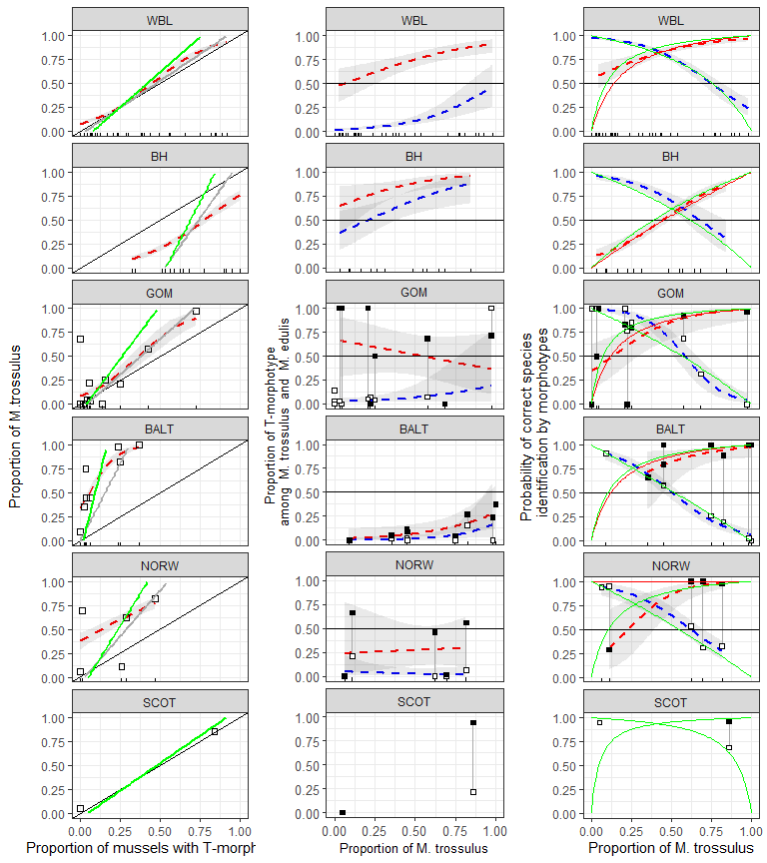

Figure ++. Predictive power of morphotype test in different regions. (A) Dependence of Ptros on proportion of T-morphotype mussels. Dotted line is empirical regression line (Model 7). Solid gray line - prediction accordingly to Eq. 3. Solid black lines represent Y=X dependence. (B) Probability to find a mussel with T-morphotype among M.edulis and M.trossulus. Dotted lines correspond to regression Model 8. Black squares - M.trossulus, white - M.edulis. (C) Probability of correct species identification by morphotype-test. Dotted lines are empirical regression lines (Model 6). Sold red line - prediction by Eq.1, Solid blue line - prediction by Eq.2. Shedded areas around regression lines represent 95% CI. For WBL and BH dots represent testing data sets in all other cases dots represent data used for constructing corresponding regression models.

Table ++. Predicted values of probability of correct species identification by mussel morphotype in mixed populations (Ptros = 0.5) in different geographical regions. Low and upper boundaries of 95% conficencal intervals are given for predicted values.

|  |  |  |  |  |  |  |
| --- | --- | --- | --- | --- | --- | --- |
| Subset | P(edu|E) |  |  | P(tros|T) |  |  |
|  | Predicted | Low | Up | Predicted | Low | Up |
| WBL | 0.77 | 0.73 | 0.81 | 0.85 | 0.82 | 0.89 |
| BH | 0.7 | 0.61 | 0.78 | 0.57 | 0.51 | 0.63 |
| GOM | 0.66 | 0.54 | 0.77 | 0.86 | 0.68 | 0.95 |
| BALT | 0.51 | 0.44 | 0.58 | 0.82 | 0.58 | 0.94 |
| NORW | 0.64 | 0.53 | 0.74 | 0.86 | 0.68 | 0.95 |

Table +. Proportion of mussels correctly identified by morphotype test in different regions

|  |  |  |
| --- | --- | --- |
| Region | E-morphotype as M.edulis | T-morphotype as M.trossulus |
| WBL | 0.74 | 0.72 |
| BH | 0.76 | 0.02 |
| GOM | 0.82 | 0.62 |
| BALT | 0.00 | 0.81 |
| NORW | 0.00 | 0.92 |

## Using the probability theory equation (Eq 1, 2, 3) for express assessments by morphotype test

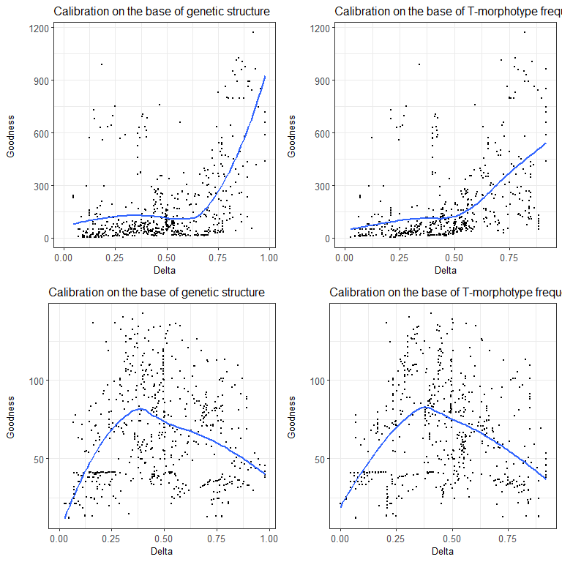

Figure +. Correspondence between regression and theoretical models. Each point corresponds to one of the possible pairs of populations from modelling data set (White Sea joined with low salinity Barens Sea). OX axis represents the differencу in genetic structre for each pair of populations. OY axis represents correspondence between prediction of regression model and theoretical model. Lines represent LOESS-smoother. (A ) Model 7 describing the dependence of proportion of M.trossulus (Ptros) on proportion of T-morphotype (P_T) ; (B) Model 6 describing the dependence of probability of correct species identification on proportion of M.trossulus and morphotype.

## Формулы для моделей

|  |  |  |  |
| --- | --- | --- | --- |
| Region | Model 4 | Model 6 E-morphotype | Model 6 T-morphotype |
| WSBL |  |  |  |
| BH |  |  |  |
| GOM |  |  |  |
| BALT |  |  |  |
| NORW |  |  |  |

## Предсказания формул Eq3 and Eq1, Eq2

Рассматривается два тип калибровочных выборок. 1. Калибровочные выборки, основанные на максимально различных генетических структурах и максимально смешанных генетических структурах. В качестве оценки генетической структуры рассматривается частота M.trossulus (Ptros) 2. Калибровочные выборки, основанные на максимально различных частотах T-морфотипа и на макимально близких к 0.5 частотах T-морфотипа.

Поведение Goodness описано выше.

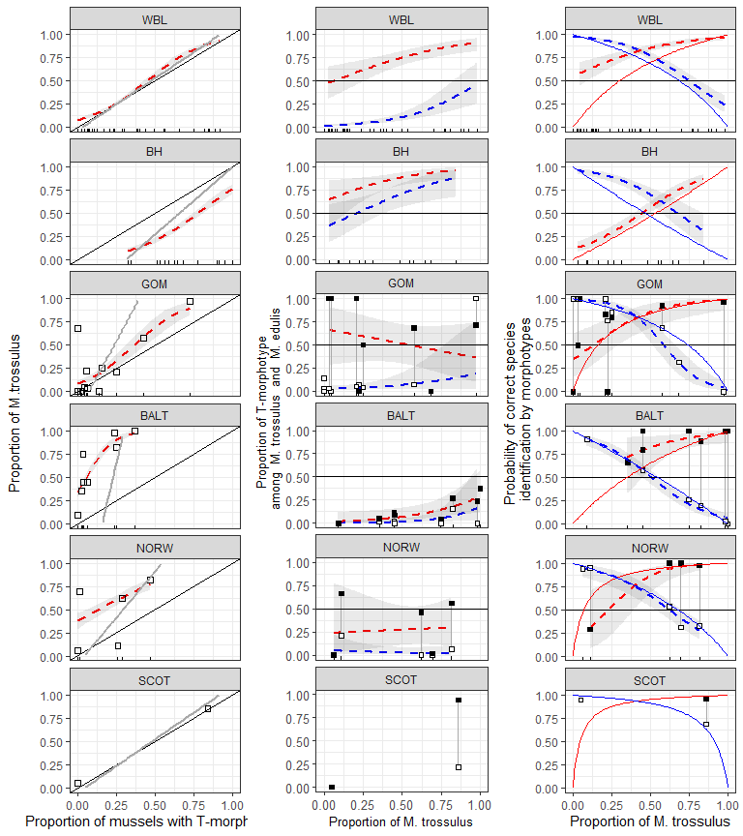

Calibration on the base of genetic structure

|  |  |  |  |  |  |  |  |  |  |  |
| --- | --- | --- | --- | --- | --- | --- | --- | --- | --- | --- |
| pop | PT | Ptros_obs | P_MT_T_obs | P_ME_E_obs | Ptros_Eq3 | P_MT_T_Eq1 | P_ME_E_Eq2 | max_mix | max_dif | Set |
| abram | 0.289 | 0.400 | 0.846 | 0.781 | 0.294 | 0.721 | 0.882 | 0 | 0 | WBL |
| belok | 0.303 | 0.318 | 0.700 | 0.848 | 0.310 | 0.736 | 0.874 | 0 | 0 | WBL |
| belok2 | 0.920 | 0.980 | 0.978 | 0.000 |  |  |  | 0 | 1 | WBL |
| berzakol | 0.064 | 0.085 | 1.000 | 0.977 | 0.042 | 0.214 | 0.986 | 0 | 0 | WBL |
| chupa | 0.381 | 0.702 | 0.906 | 0.423 | 0.398 | 0.804 | 0.825 | 0 | 0 | WBL |
| fr | 0.236 | 0.291 | 0.692 | 0.833 | 0.235 | 0.657 | 0.910 | 0 | 0 | WBL |
| ivan2 | 0.078 | 0.118 | 1.000 | 0.957 | 0.058 | 0.278 | 0.980 | 0 | 0 | WBL |
| ivan3 | 0.654 | 0.769 | 0.971 | 0.611 | 0.703 | 0.936 | 0.568 | 0 | 0 | WBL |
| kanal | 0.848 | 0.891 | 0.897 | 0.143 | 0.921 | 0.986 | 0.211 | 0 | 0 | WBL |
| kovda | 0.122 | 0.163 | 1.000 | 0.953 | 0.108 | 0.428 | 0.963 | 0 | 0 | WBL |
| luv_korg | 0.047 | 0.070 | 1.000 | 0.976 | 0.023 | 0.126 | 0.993 | 0 | 0 | WBL |
| luv_mat | 0.208 | 0.125 | 0.600 | 1.000 | 0.204 | 0.614 | 0.924 | 0 | 0 | WBL |
| mi | 0.494 | 0.776 | 0.976 | 0.419 | 0.524 | 0.872 | 0.739 | 0 | 0 | WBL |
| niva_sl | 0.561 | 0.439 | 0.696 | 0.889 | 0.599 | 0.903 | 0.676 | 0 | 0 | WBL |
| nm | 0.000 | 0.000 |  | 1.000 |  |  |  | 0 | 1 | WBL |
| nm_last | 0.400 | 0.360 | 0.800 | 0.933 | 0.419 | 0.817 | 0.812 | 0 | 0 | WBL |
| oenij | 0.750 | 0.875 | 1.000 | 0.500 | 0.811 | 0.964 | 0.420 | 0 | 0 | WBL |
| padan | 0.000 | 0.033 |  | 0.967 |  |  |  | 0 | 0 | WBL |
| porya | 0.095 | 0.143 | 1.000 | 0.947 | 0.077 | 0.342 | 0.974 | 0 | 0 | WBL |
| rya | 0.554 | 0.378 | 0.561 | 0.848 | 0.592 | 0.900 | 0.683 | 0 | 0 | WBL |
| salnij | 0.821 | 0.923 | 1.000 | 0.429 | 0.890 | 0.981 | 0.277 | 0 | 0 | WBL |
| sevsk | 0.389 | 0.537 | 1.000 | 0.758 | 0.406 | 0.810 | 0.820 | 1 | 0 | WBL |
| umba | 0.438 | 0.495 | 0.804 | 0.746 | 0.462 | 0.842 | 0.784 | 1 | 0 | WBL |
| umba_06 | 0.000 | 0.000 |  | 1.000 |  |  |  | 0 | 0 | WBL |
| umba_bridge | 0.000 | 0.000 |  | 1.000 |  |  |  | 0 | 0 | WBL |
| umba_kamni | 0.000 | 0.000 |  | 1.000 |  |  |  | 0 | 0 | WBL |
| umba_pikut | 0.233 | 0.433 | 1.000 | 0.739 | 0.232 | 0.652 | 0.912 | 0 | 0 | WBL |
| umba_pil | 0.886 | 0.773 | 0.872 | 1.000 | 0.964 | 0.994 | 0.104 | 0 | 0 | WBL |
| umba_pioner | 0.000 | 0.025 |  | 0.975 |  |  |  | 0 | 0 | WBL |
| umba_sovhoz | 0.026 | 0.132 | 1.000 | 0.892 | 0.000 | 0.000 | 1.000 | 0 | 0 | WBL |
| vor1 | 0.209 | 0.070 | 0.111 | 0.941 | 0.205 | 0.616 | 0.924 | 0 | 0 | WBL |
| vor2 | 0.000 | 0.051 |  | 0.949 |  |  |  | 0 | 0 | WBL |
| vor5 | 0.070 | 0.047 | 0.667 | 1.000 | 0.049 | 0.241 | 0.984 | 0 | 0 | WBL |
| voronya | 0.109 | 0.152 | 1.000 | 0.951 | 0.092 | 0.387 | 0.968 | 0 | 0 | WBL |
| yokanga | 0.169 | 0.237 | 0.900 | 0.898 | 0.161 | 0.543 | 0.942 | 0 | 0 | WBL |
| zmis | 0.842 | 0.807 | 0.938 | 0.889 | 0.915 | 0.985 | 0.226 | 0 | 0 | WBL |
| banka | 0.512 | 0.095 | 0.070 | 0.878 |  |  |  | 0 | 0 | BH |
| bukhtovka | 0.625 | 0.225 | 0.280 | 0.867 | 0.231 | 0.265 | 0.844 | 0 | 0 | BH |
| dz_banka | 0.341 | 0.091 | 0.233 | 0.983 |  |  |  | 0 | 0 | BH |
| dz_lit | 0.528 | 0.034 | 0.043 | 0.976 | 0.003 | 0.003 | 0.998 | 0 | 1 | BH |
| ivan_buy | 1.000 | 0.682 | 0.682 |  |  |  |  | 0 | 0 | BH |
| ivan_us | 0.327 | 0.163 | 0.500 | 1.000 |  |  |  | 0 | 0 | BH |
| kuvsh | 0.900 | 0.550 | 0.556 | 0.500 | 0.879 | 0.897 | 0.183 | 0 | 0 | BH |
| seredina | 0.949 | 0.571 | 0.591 | 0.800 | 0.995 | 0.996 | 0.009 | 0 | 0 | BH |
| seredina_sub | 0.681 | 0.483 | 0.494 | 0.541 | 0.363 | 0.407 | 0.740 | 1 | 0 | BH |
| tu_old | 0.911 | 0.844 | 0.902 | 0.750 | 0.905 | 0.920 | 0.145 | 0 | 1 | BH |
| ustie | 0.774 | 0.547 | 0.622 | 0.708 | 0.581 | 0.625 | 0.540 | 1 | 0 | BH |
| ustie_sub | 0.588 | 0.311 | 0.386 | 0.796 | 0.145 | 0.169 | 0.906 | 0 | 0 | BH |
| vol | 0.646 | 0.646 | 0.762 | 0.565 | 0.281 | 0.320 | 0.806 | 0 | 0 | BH |
| yarn02 | 0.565 | 0.261 | 0.462 | 1.000 | 0.090 | 0.107 | 0.942 | 0 | 0 | BH |
| BI | 0.043 | 0.043 | 1.000 | 1.000 | 0.006 | 0.045 | 0.995 | 0 | 0 | GOM |
| CBCP | 0.000 | 0.683 |  | 0.317 |  |  |  | 1 | 0 | GOM |
| CBE | 0.722 | 0.972 | 0.962 | 0.000 |  |  |  | 0 | 1 | GOM |
| CBSC | 0.056 | 0.222 | 0.000 | 0.765 | 0.024 | 0.156 | 0.982 | 0 | 0 | GOM |
| CBSL | 0.424 | 0.576 | 0.929 | 0.684 | 0.570 | 0.908 | 0.501 | 1 | 0 | GOM |
| JPC | 0.020 | 0.000 | 0.000 | 1.000 |  |  |  | 0 | 1 | GOM |
| KIM | 0.062 | 0.031 | 0.500 | 1.000 | 0.034 | 0.211 | 0.974 | 0 | 0 | GOM |
| MDICOA | 0.029 | 0.000 | 0.000 | 1.000 |  |  |  | 0 | 0 | GOM |
| MDRE | 0.250 | 0.208 | 0.833 | 1.000 | 0.312 | 0.772 | 0.746 | 0 | 0 | GOM |
| MDRW | 0.156 | 0.250 | 0.800 | 0.852 | 0.173 | 0.610 | 0.864 | 0 | 0 | GOM |
| PH | 0.138 | 0.000 | 0.000 | 1.000 | 0.146 | 0.561 | 0.886 | 0 | 0 | GOM |
| VH | 0.000 | 0.000 |  | 1.000 |  |  |  | 0 | 0 | GOM |
| kast05 | 0.000 | 0.091 |  | 0.909 | 0.000 | 0.000 | 1.000 | 0 | 1 | BALT |
| kast87 | 0.064 | 0.449 | 0.800 | 0.575 | 0.207 | 0.657 | 0.808 | 1 | 0 | BALT |
| Limh08 | 0.025 | 0.353 | 0.667 | 0.655 | 0.081 | 0.394 | 0.925 | 0 | 0 | BALT |
| Limh88 | 0.035 | 0.748 | 1.000 | 0.261 | 0.112 | 0.482 | 0.897 | 0 | 0 | BALT |
| Solvesborg | 0.371 | 1.000 | 1.000 | 0.000 |  |  |  | 0 | 1 | BALT |
| Vhg05 | 0.039 | 0.451 | 1.000 | 0.571 | 0.127 | 0.516 | 0.883 | 1 | 0 | BALT |
| Vhg88 | 0.250 | 0.824 | 0.889 | 0.198 | 0.808 | 0.969 | 0.207 | 0 | 0 | BALT |
| Ystad05 | 0.236 | 0.982 | 1.000 | 0.024 | 0.764 | 0.960 | 0.254 | 0 | 0 | BALT |
| Berg_new | 0.289 | 0.622 | 1.000 | 0.531 | 0.503 | 1.000 | 0.546 | 1 | 0 | NORW |
| Bergen_MV | 0.468 | 0.815 | 0.975 | 0.326 | 0.846 | 1.000 | 0.181 | 0 | 1 | NORW |
| Bergen04 | 0.014 | 0.694 | 1.000 | 0.310 |  |  |  | 1 | 0 | NORW |
| Esp_MV | 0.259 | 0.111 | 0.286 | 0.950 | 0.446 | 1.000 | 0.602 | 0 | 0 | NORW |
| Esp04 | 0.000 | 0.062 |  | 0.938 |  |  |  | 0 | 1 | NORW |

Calibration on the base of T-morphotype frequency

|  |  |  |  |  |  |  |  |  |  |  |
| --- | --- | --- | --- | --- | --- | --- | --- | --- | --- | --- |
| pop | PT | Ptros_obs | P_MT_T_obs | P_ME_E_obs | Ptros_Eq3 | P_MT_T_Eq1 | P_ME_E_Eq2 | max_mix | max_dif | Set |
| abram | 0.289 | 0.400 | 0.846 | 0.781 | 0.294 | 0.493 | 0.842 | 0 | 0 | WBL |
| belok | 0.303 | 0.318 | 0.700 | 0.848 | 0.310 | 0.512 | 0.831 | 0 | 0 | WBL |
| belok2 | 0.920 | 0.980 | 0.978 | 0.000 |  |  |  | 0 | 1 | WBL |
| berzakol | 0.064 | 0.085 | 1.000 | 0.977 | 0.042 | 0.093 | 0.981 | 0 | 0 | WBL |
| chupa | 0.381 | 0.702 | 0.906 | 0.423 | 0.398 | 0.606 | 0.771 | 0 | 0 | WBL |
| fr | 0.236 | 0.291 | 0.692 | 0.833 | 0.235 | 0.418 | 0.878 | 0 | 0 | WBL |
| ivan2 | 0.078 | 0.118 | 1.000 | 0.957 | 0.058 | 0.126 | 0.973 | 0 | 0 | WBL |
| ivan3 | 0.654 | 0.769 | 0.971 | 0.611 | 0.703 | 0.847 | 0.483 | 0 | 0 | WBL |
| kanal | 0.848 | 0.891 | 0.897 | 0.143 | 0.921 | 0.964 | 0.160 | 0 | 0 | WBL |
| kovda | 0.122 | 0.163 | 1.000 | 0.953 | 0.108 | 0.220 | 0.948 | 0 | 0 | WBL |
| luv_korg | 0.047 | 0.070 | 1.000 | 0.976 | 0.023 | 0.051 | 0.990 | 0 | 0 | WBL |
| luv_mat | 0.208 | 0.125 | 0.600 | 1.000 | 0.204 | 0.374 | 0.896 | 0 | 0 | WBL |
| mi | 0.494 | 0.776 | 0.976 | 0.419 | 0.524 | 0.720 | 0.668 | 1 | 0 | WBL |
| niva_sl | 0.561 | 0.439 | 0.696 | 0.889 | 0.599 | 0.777 | 0.597 | 0 | 0 | WBL |
| nm | 0.000 | 0.000 |  | 1.000 |  |  |  | 0 | 1 | WBL |
| nm_last | 0.400 | 0.360 | 0.800 | 0.933 | 0.419 | 0.627 | 0.755 | 0 | 0 | WBL |
| oenij | 0.750 | 0.875 | 1.000 | 0.500 | 0.811 | 0.909 | 0.340 | 0 | 0 | WBL |
| padan | 0.000 | 0.033 |  | 0.967 |  |  |  | 0 | 0 | WBL |
| porya | 0.095 | 0.143 | 1.000 | 0.947 | 0.077 | 0.163 | 0.964 | 0 | 0 | WBL |
| rya | 0.554 | 0.378 | 0.561 | 0.848 | 0.592 | 0.771 | 0.605 | 1 | 0 | WBL |
| salnij | 0.821 | 0.923 | 1.000 | 0.429 | 0.890 | 0.950 | 0.215 | 0 | 0 | WBL |
| sevsk | 0.389 | 0.537 | 1.000 | 0.758 | 0.406 | 0.615 | 0.764 | 0 | 0 | WBL |
| umba | 0.438 | 0.495 | 0.804 | 0.746 | 0.462 | 0.666 | 0.721 | 0 | 0 | WBL |
| umba_06 | 0.000 | 0.000 |  | 1.000 |  |  |  | 0 | 0 | WBL |
| umba_bridge | 0.000 | 0.000 |  | 1.000 |  |  |  | 0 | 0 | WBL |
| umba_kamni | 0.000 | 0.000 |  | 1.000 |  |  |  | 0 | 0 | WBL |
| umba_pikut | 0.233 | 0.433 | 1.000 | 0.739 | 0.232 | 0.413 | 0.880 | 0 | 0 | WBL |
| umba_pil | 0.886 | 0.773 | 0.872 | 1.000 | 0.964 | 0.984 | 0.076 | 0 | 0 | WBL |
| umba_pioner | 0.000 | 0.025 |  | 0.975 |  |  |  | 0 | 0 | WBL |
| umba_sovhoz | 0.026 | 0.132 | 1.000 | 0.892 | 0.000 | 0.000 | 1.000 | 0 | 0 | WBL |
| vor1 | 0.209 | 0.070 | 0.111 | 0.941 | 0.205 | 0.375 | 0.896 | 0 | 0 | WBL |
| vor2 | 0.000 | 0.051 |  | 0.949 |  |  |  | 0 | 0 | WBL |
| vor5 | 0.070 | 0.047 | 0.667 | 1.000 | 0.049 | 0.107 | 0.977 | 0 | 0 | WBL |
| voronya | 0.109 | 0.152 | 1.000 | 0.951 | 0.092 | 0.192 | 0.956 | 0 | 0 | WBL |
| yokanga | 0.169 | 0.237 | 0.900 | 0.898 | 0.161 | 0.308 | 0.921 | 0 | 0 | WBL |
| zmis | 0.842 | 0.807 | 0.938 | 0.889 | 0.915 | 0.961 | 0.172 | 0 | 0 | WBL |
| banka | 0.512 | 0.095 | 0.070 | 0.878 | 0.290 | 0.261 | 0.681 | 1 | 0 | BH |
| bukhtovka | 0.625 | 0.225 | 0.280 | 0.867 | 0.455 | 0.419 | 0.511 | 0 | 0 | BH |
| dz_banka | 0.341 | 0.091 | 0.233 | 0.983 | 0.041 | 0.036 | 0.953 | 0 | 0 | BH |
| dz_lit | 0.528 | 0.034 | 0.043 | 0.976 | 0.314 | 0.284 | 0.656 | 1 | 0 | BH |
| ivan_buy | 1.000 | 0.682 | 0.682 |  | 1.000 | 1.000 | 0.000 | 0 | 1 | BH |
| ivan_us | 0.327 | 0.163 | 0.500 | 1.000 | 0.020 | 0.018 | 0.977 | 0 | 1 | BH |
| kuvsh | 0.900 | 0.550 | 0.556 | 0.500 | 0.855 | 0.836 | 0.129 | 0 | 0 | BH |
| seredina | 0.949 | 0.571 | 0.591 | 0.800 | 0.926 | 0.915 | 0.065 | 0 | 0 | BH |
| seredina_sub | 0.681 | 0.483 | 0.494 | 0.541 | 0.536 | 0.500 | 0.430 | 0 | 0 | BH |
| tu_old | 0.911 | 0.844 | 0.902 | 0.750 | 0.871 | 0.854 | 0.115 | 0 | 0 | BH |
| ustie | 0.774 | 0.547 | 0.622 | 0.708 | 0.671 | 0.638 | 0.300 | 0 | 0 | BH |
| ustie_sub | 0.588 | 0.311 | 0.386 | 0.796 | 0.401 | 0.367 | 0.565 | 0 | 0 | BH |
| vol | 0.646 | 0.646 | 0.762 | 0.565 | 0.485 | 0.450 | 0.480 | 0 | 0 | BH |
| yarn02 | 0.565 | 0.261 | 0.462 | 1.000 | 0.368 | 0.335 | 0.600 | 0 | 0 | BH |
| BI | 0.043 | 0.043 | 1.000 | 1.000 |  |  |  | 0 | 0 | GOM |
| CBCP | 0.000 | 0.683 |  | 0.317 |  |  |  | 0 | 1 | GOM |
| CBE | 0.722 | 0.972 | 0.962 | 0.000 |  |  |  | 1 | 1 | GOM |
| CBSC | 0.056 | 0.222 | 0.000 | 0.765 |  |  |  | 0 | 0 | GOM |
| CBSL | 0.424 | 0.576 | 0.929 | 0.684 |  |  |  | 1 | 0 | GOM |
| JPC | 0.020 | 0.000 | 0.000 | 1.000 |  |  |  | 0 | 0 | GOM |
| KIM | 0.062 | 0.031 | 0.500 | 1.000 |  |  |  | 0 | 0 | GOM |
| MDICOA | 0.029 | 0.000 | 0.000 | 1.000 |  |  |  | 0 | 0 | GOM |
| MDRE | 0.250 | 0.208 | 0.833 | 1.000 | 0.549 | 0.865 | 0.706 | 0 | 0 | GOM |
| MDRW | 0.156 | 0.250 | 0.800 | 0.852 | 0.261 | 0.650 | 0.892 | 0 | 0 | GOM |
| PH | 0.138 | 0.000 | 0.000 | 1.000 | 0.204 | 0.575 | 0.919 | 0 | 0 | GOM |
| VH | 0.000 | 0.000 |  | 1.000 |  |  |  | 0 | 0 | GOM |
| kast05 | 0.000 | 0.091 |  | 0.909 |  |  |  | 0 | 0 | BALT |
| kast87 | 0.064 | 0.449 | 0.800 | 0.575 |  |  |  | 0 | 0 | BALT |
| Limh08 | 0.025 | 0.353 | 0.667 | 0.655 |  |  |  | 0 | 0 | BALT |
| Limh88 | 0.035 | 0.748 | 1.000 | 0.261 |  |  |  | 0 | 0 | BALT |
| Solvesborg | 0.371 | 1.000 | 1.000 | 0.000 |  |  |  | 1 | 1 | BALT |
| Vhg05 | 0.039 | 0.451 | 1.000 | 0.571 |  |  |  | 0 | 0 | BALT |
| Vhg88 | 0.250 | 0.824 | 0.889 | 0.198 | 0.656 | 0.782 | 0.387 | 1 | 1 | BALT |
| Ystad05 | 0.236 | 0.982 | 1.000 | 0.024 | 0.559 | 0.705 | 0.487 | 0 | 0 | BALT |
| Berg_new | 0.289 | 0.622 | 1.000 | 0.531 | 0.493 | 0.928 | 0.684 | 1 | 1 | NORW |
| Bergen_MV | 0.468 | 0.815 | 0.975 | 0.326 | 0.849 | 0.987 | 0.273 | 1 | 1 | NORW |
| Bergen04 | 0.014 | 0.694 | 1.000 | 0.310 |  |  |  | 0 | 0 | NORW |
| Esp_MV | 0.259 | 0.111 | 0.286 | 0.950 | 0.434 | 0.911 | 0.733 | 0 | 0 | NORW |
| Esp04 | 0.000 | 0.062 |  | 0.938 |  |  |  | 0 | 0 | NORW |

